CMPUT 291 Project 1 Design Document

Aaron Padlesky & Lin Tong 1 & Ng Yuen Tung

1263918// Student 1 ID // Student 2 ID

Assignment due: Mar. 21, 2014

(a) General Overview
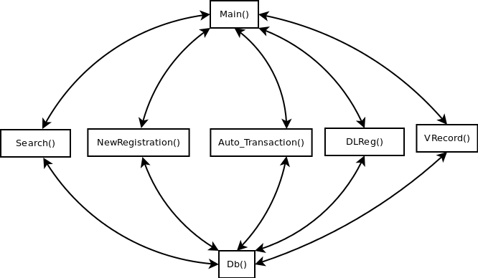
Main menu allows the user to choose one of the five actions that you can do. The five actions: search, new registration, auto transaction, driver licence registration, and record violatoin. Each of these five methods have its own flow once inside the that method.

(b) Design
- Classes & Methods
Main(): prompts the user to give there username and password to connect with the database. After words it gives text stating keywords that direct them around to the various methods. After a word is typed in if it doesn’t match a keyword it repeats the keywords with an error message saying you did not enter a key word correctly.

Search(): prompts the user stating the keywords that you use for the three different searchs. If a keyword is not typed in or one is typed in incurrectly then there is an text stating that the input did not match a keyword; it then shows you a command if you want to relist the keywords. If a keyword is typed correctly it then displays further instructions depending on the search word. If its the second search it asks if you are entering either a sin number or a licence number after which it asks for input.

NewRegistration(): takes the user through the steps for registering a new car. Goes step by step testing the input to make sure it is correct. If a owner isn’t in the database it then takes you through the steps of entering in an owner into the database.

Auto_Transaction(): takes the user through the steps of entering in a new auto transaction. If a owner isn’t in the database it then takes you through the steps of entering in an owner into the database. If there was a previous owner to the vehicle he is then removed and the buyer is made the new primary owner. Exits upon completing an auto transaction.

DLReg(): takes the user through the steps of entering in registering a person for a driver licence. It first enters the person into the database, then taking them through the extra information of entering in the required information for a licence. If the sin matches one already in the database an appropriate message is shown. An image is also shown able to be added into the database.

VRecord(): takes you through the steps of entering in a ticket. You can enter in the ticket of the owner itself if caught in person, or to a vehicle relating the ticket to the primary owner as in parking ticket and photo radar.

Db(): this class handles all the database statements. It has many functions in it that are called by the five actions a user can perform. It is initiated in the main method where it stores the username and password, this allows the other methods only needing to be called by the getMeMyDBPlx() method. Allowing other methods to then just use the methods in the db class.

(c) Testing Strategy
Testing was done through going through the program using a black box testing method. This was we tested out the functions of the code without looking inside the functions themselves and only know the different types of parameteres to pass in. The values passed in that were tested were wrong input, one above the high boundry, one below the low boundry and a safe value. We also did white box testing where we looked at the code to figure out the flow of the code and tested to make sure that all parts of the function were reached inside the code. This allowed us to not only test the various inputs but make sure we could reach all parts of the code. Using these two in combination lead us to be able to find majority of the bugs. As known in computer science though you can never find all the bugs.

(d) Group Work Strategy
- Method of Coordination
How our group functioned was we all divided up the methods that needed to be done by each other. The person who did search would only get one method and would thus also be in charge of the the extra classes or methods needed throughout the document. After dividing up the work our group used GitHub as a base for the code where we would upload and download the code from and share with each other. We did not use a general database that was shared amongst each other. We each used our own database to begin with and each of us tested our own functions. There was a general script as well that was shared on GitHub and was used to keep track of test data created by each other and a way to make sure our databases were the same.

- Break Down
Search() and Main() were done by Aaron Padlesky. Auto_Transaction and NewRegistration were done by Lin Tong (Joe). DLReg() and VRecord() were done by Ng Yuen Tung (Brigette). Db() was done collaboratively.

